Supplementary material file 5：Temporal bone CT scan of three IP3 patients.

Fig. A–C: Temporal bone CT images of the patients demonstrating the dilation of the lateral end of the internal auditory canal (IAM) and the basal turn of the cochlea was incompletely separated from IAC. Red arrows indicate the dilation of the lateral end of the IAM.

NT42-Ⅱ:5

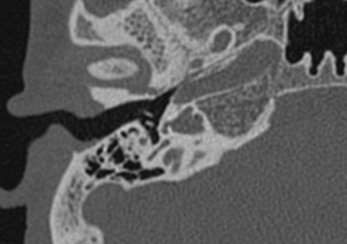
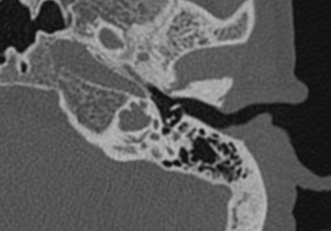
L
R

A

NT42-Ⅳ:1

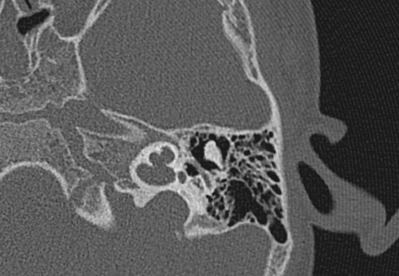
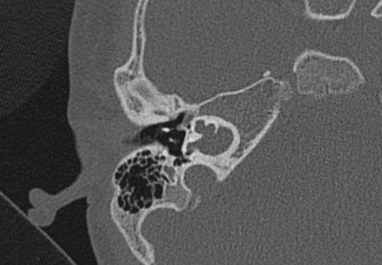
L
R

B

NT43-Ⅳ:2
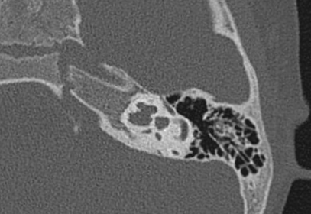
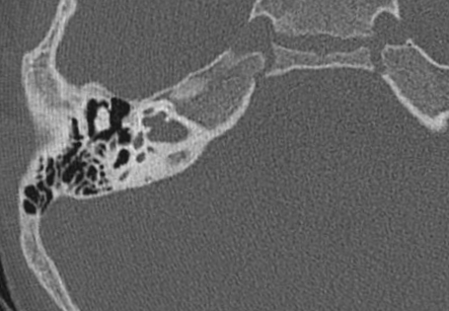
L
R

C

